Atmosphere Composition Notes 17.1
- When we think of what air is made of the first two chemicals that come to mind are ____________ and ___________________, BUT more than ¾ of air is made of ____________. Also, ____________ has more than double the percentage of ____________________.
Dry Air
- We don’t think about ____________ and __________, because our lungs can’t use these gasses. So, whatever amount we breath in we simply ___________ ____ again.
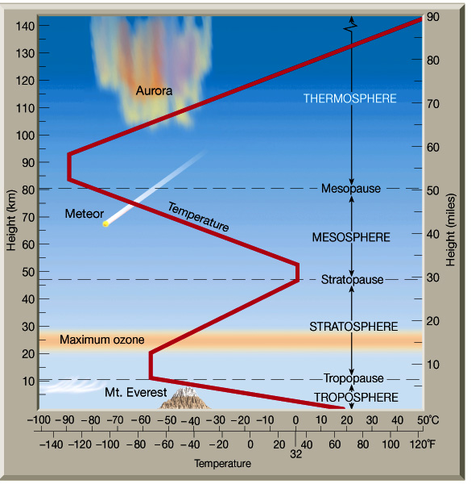
- While insignificant in deserts, another extremely important part of most air is water vapor (a.k.a. __________). Without this there would be no ________ or ________. In humid areas, _________ _________ can make up to 4% of the air.
Atmospheric Structure
- When sunlight hits the Earth, the Earth gets __________. Generally speaking, ordinary temperature gets ________ are you get ___________ in the atmosphere.
- The lowest layer of the atmosphere is the _____________. It contains almost all the ___________, _______ ________, and ______. It ends at the ____________ (12km, 7.5 mi).
- The next layer is the ______________. This layer contains ________, which is needed to absorb UV and X-ray radiation so people can live on Earth’s ___________. This absorption causes the stratosphere to get __________ with increasing height. It ends at the ____________ (52km, 32mi). (Side Note: Limit to jet planes.)
- Next is the ______________. Again temperature ____________ with increasing height. This layer protects us from ___________. It ends at the _____________(80km, 50mi).
- The last layer we will study is the ______________, which extends to an average height of 750km (465mi). This layer absorbs solar wind (high energy electrons and protons from the _____). This absorption creates the __________ seen near Earth’s poles and also causes the temperature to __________ with increasing height. (Side Note: while hot in terms of atomic speed, there is too little atmosphere to keep a person warm.)
Seasons and Day Length Notes 17.1b
- Earth’s seasons are caused by Earth’s orbital _______.
- During the Northern Winter Solstice the Sun is directly above the Tropic of Capricorn (23.5⁰ S latitude), every place North of the Arctic Circle (65.5⁰ N lat) is in 24hr darkness, and every place South of the Antarctic Circle (65.5⁰ S) is in 24hr daylight.
- During the Northern Summer Solstic the Sun is directly above the ________________ (_______), every place North of the _____________ is in _____________, and every place South of the __________________ is in ______________.
- During the Equinoxes, all places on the Earth get an __________ number of hour of light and dark (_____ hours). (Fig.8 pg. 482)

How Energy is Transferred Notes 17.2
- Energy from _______ places flows to ________ places by three different methods: touch, mixing, and light (electromagnetic radiation).
- Convection is the __________ of a fluid that transfers heat (and other things).
- Conduction is heat lost or gained by _________.
- Radiation is heat transferred in the form of ________ (either visible or invisible).
- Radiation is always present. Conduction is present if there is matter. Convection is present if matter is in the _______ or __________ phase.
- On a cold day, you feel cold because cold air is “touching” your _____ body. So, energy ____________ out of your body to the air. The weather feels even ___________ though when ______________, because convection transfers energy ___________ than conduction.
- A wok on the stove feels ____________ if you touch it than if you just hold your hand near it. This is because conduction is ____________ than radiation and transferring energy.
- The Sun transfers energy out of itself primarily through _____________, because it is surrounded by _____________ making conduction and convection ______________.
Where Sunlight Goes Notes 17.2b
- Plants need __________ to do photosynthesis. So, all life depends on _________ energy. Not all light from the Sun the reaches Earth gets used by _________.
- 30% is simply ___________ off clouds, ice, etc. back into outer space. 20% gets absorbed by the ___________ before reaching the ground. So, only _______ of sunlight is absorbed by the ground. Plants use only a small fraction of this light, most light just makes the land and oceans __________.
- All ________ objects give off infrared light and heat. So, the land and ocean release the _________ energy they absorbed as infrared light and heat.
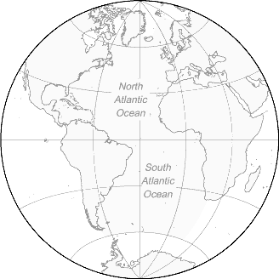
- Greenhouse gasses like water vapor, __________________, and methane make it difficult for infrared light to escape Earth. This trapping of infrared light is called the ___________ Effect. People worry a lot about __________________ emissions adding to the Greenhouse Effect and making Earth so _____ that droughts and huge storms become common. Without any ____________ __________, however, Earth’s average temperature would be -18ºC (-0.4ºF) and Earth would quickly freeze over.
Reflected Sunlight Emitted Infrared Light

Sunlight Budget Diagrams

Some Reasons Temperatures Vary on Earth Notes 17.3
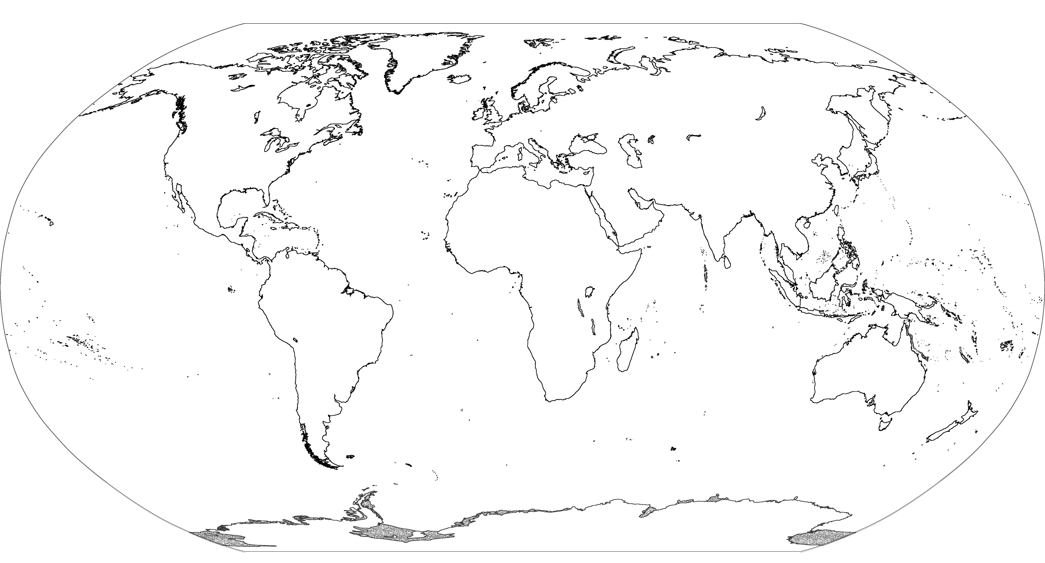
- The number one thing that determines temperature is how much __________ hits an area. This is why the ____________ is hot. It also explains why the poles are always _______ but warmer in __________ than __________. Fig. 20

- Oceans _________ change temperature much. So, being close to an ocean tends to make temperatures _______ extreme, esp. if wind blows from the ocean. Fig. 15, 16

- Mountaintops are __________ than valleys. So, high altitude __________ average temperature.

- Finally, heavy cloud cover makes temperatures ________ extreme, because clouds _________ sunlight during the day, but ________ infrared light at night.

